# Engineering Exploration

Project Report On

**Write the title here**

By

|  |  |  |
| --- | --- | --- |
| M.Poojith Reddy | - | Roll number |
| M.Yaswanth | - | Roll number |
| Vishwanth Raghava | - | Roll number |
| Shivek Wali | - | Roll number |
| NAME OF THE CANDIDATE | - | Roll number |

Under the Mentorship of **Faculty name** Designation



Branch: **Department of …………………………….**

**Submitted to**

**Department of Mechanical Engineering CHAITANYA BHARATHI INSTITUTE OF TECHNOLOGY (A)**

**(Affiliated to Osmania University) Gandipet, Hyderabad- 500075**

**2021 - 2022**



**CERTIFICATE**

This is to certify that the project entitled **“Write title here”** by the following students has carried out under my mentorship**.**

|  |  |  |  |
| --- | --- | --- | --- |
| 1 | NAME OF THE CANDIDATE | - | Roll number |
| 2 | NAME OF THE CANDIDATE | - | Roll number |
| 3 | NAME OF THE CANDIDATE | - | Roll number |
| 4 | NAME OF THE CANDIDATE | - | Roll number |
| 5 | NAME OF THE CANDIDATE | - | Roll number |

**Mentor Name Designation**

**Department of ………………………………..**

**CONTENTS**

**ABSTRACT**

Colleges use websites for a multitude of reasons. With their main focus usually on campus and campus life. First and foremost a college website is a sales tool showcasing programs offered, the campus, and student life. For a prospective student, the college website is their first look at what the next few years of their life will be.

Colleges understand that their website is a sales tool; they will have every bit of information you will need to make the decision to go to their school without ever having to actually talk to someone. They will also have plenty of opportunities showcased to request information or talk to an advisor. These will come in the form of Web Forms or Brochures.

Generally on the Home Page the core fundamentals will be displayed. Meaning a breakdown of areas of study; where can I apply; can I get financial aid; news feed; calendar of events. If you are potential student generally these are the most important areas to you. They let you get a feel for the school and let you get the most out of your visit to the site all in one place.

Colleges also use their websites as a powerful tool for faculty and enrolled students. It is the base for communication between faculty and students for class work. The website can be used to relay important information not only about classes and events but also as a way to communicate in emergency situations.

Colleges use their site to take donations to help fund programs and the school itself. Colleges use websites to reach not only student enrollment goals but also financial goals. Whether they are running a fundraiser or simply taking donations in general. The website is a gate way for users to get to the right place.

**Keywords:** Home, timetable, holidays list , syllabus

CHAPTER-1

INTRODUCTION

**Problem Statement:**

**Motivation:**

There are 3 websites for CBIT college but we are trying to design a website for multiple reasons. We want to increase our knowledge in web development and get experience from it. This was our first attempt to design a website which was of help to understand HTML, CSS, JS. We also wanted to know what was required to develop a complete website.

The idea of choosing this project was based on the need of a user friendly interface for the college students and teachers and for the daily check of timetables. This website is used for checking timetables and holidays list since there was no timetables in the main website which was a major inconvienence for newly joined students and teachers for cross checking the classes they have.

**Introduction:**

For our engineering exploration project we as a group of students decided to make a website for our college which have a beautiful background and a user friendly interface for the user to interact with the website. We wanted to design a website for checking the timetable and holidays list which is useful to the students who are accesing the website. Our official website have lots of things, promotions etc. so it is difficult to search for timetables, holidays list, syllabus etc. we tried to solve this problem by creating the website whose sole purpose is displaying the time table, holidays etc.

**Project Objectives:**

1. To create a website which displays the timetables and allows us to download the PDF of the syllabus copy.
2. To create a website whose sole purpose is displaying the timetable the user wanted and syllabus of the semester he is going to study.

**Advantages:**

It helps us to reduce the searching time of the timetable in the main website and to download syllabus of required semester.

CHAPTER-2

BASICS

**HTML:**

The HyperText Markup Language or HTML is the standard markup language for documents designed to be displayed in a web browser. It can be assisted by technologies such as Cascading Style Sheets (CSS) and scripting languages such as JavaScript.

Web browsers receive HTML documents from a web server or from local storage and render the documents into multimedia web pages. HTML describes the structure of a web page semantically and originally included cues for the appearance of the document.

HTML elements are the building blocks of HTML pages. With HTML constructs, images and other objects such as interactive forms may be embedded into the rendered page. HTML provides a means to create structured documents by denoting structural semantics for text such as headings, paragraphs, lists, links, quotes and other items. HTML elements are delineated by tags, written using angle brackets. Tags such as <img /> and <input /> directly introduce content into the page. Other tags such as <p> surround and provide information about document text and may include other tags as sub-elements. Browsers do not display the HTML tags but use them to interpret the content of the page.

HTML can embed programs written in a scripting language such as JavaScript, which affects the behavior and content of web pages. Inclusion of CSS defines the look and layout of content. The World Wide Web Consortium (W3C), former maintainer of the HTML and current maintainer of the CSS standards, has encouraged the use of CSS over explicit presentational HTML since 1997.[2] A form of HTML, known as HTML5, is used to display video and audio, primarily using the <canvas> element, in collaboration with javascript.

**CSS:**

Cascading Style Sheets (CSS) is a style sheet language used for describing the presentation of a document written in a markup language such as HTML or XML (including XML dialects such as SVG, MathML or XHTML).[1] CSS is a cornerstone technology of the World Wide Web, alongside HTML and JavaScript.[2]

CSS is designed to enable the separation of presentation and content, including layout, colors, and fonts.[3] This separation can improve content accessibility; provide more flexibility and control in the specification of presentation characteristics; enable multiple web pages to share formatting by specifying the relevant CSS in a separate .css file, which reduces complexity and repetition in the structural content; and enable the .css file to be cached to improve the page load speed between the pages that share the file and its formatting.

Separation of formatting and content also makes it feasible to present the same markup page in different styles for different rendering methods, such as on-screen, in print, by voice (via speech-based browser or screen reader), and on Braille-based tactile devices. CSS also has rules for alternate formatting if the content is accessed on a mobile device.[4]

The name cascading comes from the specified priority scheme to determine which style rule applies if more than one rule matches a particular element. This cascading priority scheme is predictable.

The CSS specifications are maintained by the World Wide Web Consortium (W3C). Internet media type (MIME type) text/css is registered for use with CSS by RFC 2318 (March 1998). The W3C operates a free CSS validation service for CSS documents.[5]

In addition to HTML, other markup languages support the use of CSS including XHTML, plain XML, SVG, and XUL.

**JavaScript:**

JavaScript often abbreviated JS, is a programming language that is one of the core technologies of the World Wide Web, alongside HTML and CSS. As of 2022, 98% of websites use JavaScript on the client side for webpage behavior, often incorporating third-party libraries. All major web browsers have a dedicated JavaScript engine to execute the code on users' devices.

JavaScript is a high-level, often just-in-time compiled language that conforms to the ECMAScript standard. It has dynamic typing, prototype-based object-orientation, and first-class functions. It is multi-paradigm, supporting event-driven, functional, and imperative programming styles. It has application programming interfaces (APIs) for working with text, dates, regular expressions, standard data structures, and the Document Object Model (DOM).

The ECMAScript standard does not include any input/output (I/O), such as networking, storage, or graphics facilities. In practice, the web browser or other runtime system provides JavaScript APIs for I/O.

JavaScript engines were originally used only in web browsers, but are now core components of some servers and a variety of applications. The most popular runtime system for this usage is Node.js.

Although Java and JavaScript are similar in name, syntax, and respective standard libraries, the two languages are distinct and differ greatly in design.

CHAPTER-3

THE CODE:

HTML CODE:

Home Page:

<!DOCTYPE html>

<html lang="en">

<head>

<meta charset="UTF-8">

<meta http-equiv="X-UA-Compatible" content="IE=edge">

<meta name="viewport" content="width=device-width, initial-scale=1.0">

<title>Home Page</title>

<link rel="stylesheet" href="style.css">

</head>

<body>

<img src="cbit_logo_2.png" style="width:auto;height:auto" alt="cbit logo" style="float:left">

<hr>

<div>

<ul>

<li><a href="/home.html">Home</a></li>

<li><a href="/index.html">Timetable</a></li>

<li><a href='/Syllabus.html'>Syllabus</a></li>

<li><a href="/holidays.html">Holidays List</a></li>

<li><a href="/about.html">About Us</a></li>

<li><a

href="https://docs.google.com/forms/d/e/1FAIpQLSdpRYJqSjN-ohFpIbCXXg7L_mJPKI-jtloSatxeIpi5VK3fUg/viewform?usp=sf_link">Contact

Us</a></li>

</ul>

</div>

<article>

<div id="home">

<h4 style="color:red">Institute Vision & Mission</h4>

<p><span style="color:rgb(3, 48, 3)">Vision :</span> “To be the center of excellence in technical education

and research”.</p>

<p><span style="color:rgb(3,48,3)">Mission :</span> “To address the emerging needs through quality technical

education and advanced research”.</p>

<h4 style="color:red">Institute Recognitions</h4>

<h4>We’re talking Self-Enlightenment.</h4>

<p>CHAITANYA BHARATHI INSTITUTE OF TECHNOLOGY, established in the Year 1979, esteemed as the Premier

Engineering Institute in the States of Telangana and Andhra Pradesh, was promoted by a Group of

Visionaries from varied Professions of Engineering, Medical, Legal and Management, with an Objective to

facilitate the Best Engineering and Management Education to the Students and contribute towards meeting

the need of Skilled and Technically conversant Engineers and Management Professionals, for the Country

that embarked on an Economic Growth Plan.</p>

<img src="https://www.cbit.ac.in/wp-content/themes/CBIT/images/placeholder.jpg" alt="connection error">

<p>The Institute, committed to Education and Innovation, started with three-Degree Courses in Engineering

for 200 Students and over the 42 Years, has emerged as a Dream Destination for; Students seeking to

excel in Engineering and Management Education, Teaching Community to progress with a rewarding Career

and Corporates to source well-rounded Engineers.</p>

<p>Stringent Academic Standards, Industry compliant Teaching Methodology, Research Projects from Private and

Public Sector Industries in Engineering and Management and Consultancy Practice, enabled the Institute

to establish its Identity in the Technical Education and is Ranked No. 1 amongst the Private Engineering

Colleges in both the Telugu Speaking States.</p>

<p>The Practices and the Culture at the Institute has always been to provide Quality Education by enhancing

the overall Educational experience of Students adopting a wide range of Academic, Practical,

Co-Curricular, Extra-Curricular Programs in the State-of-the-Art Facilities, Services and Activities to

enable the required exposure to a variety of Social, Cultural, Intellectual, Recreational Opportunities

and Challenges. Such learning experiences have enriched the lives of Students and helped them to develop

into a Multi-Skilled and Multi -Tasking Personalities that ensured success in their Careers and

Occupations. Co-curricular and Extra-Curricular activities are planned and executed through a number of

Associations, Clubs, Societies, Students’ Chapters of Professional Bodies, with a view to allow the

Students, the necessary freedom to plan and execute every effort and in the process nurture them to be

the future Leaders who learn to address Challenges and carve a path of Success.</p>

<p>In its Four Decades of existence, all the Stake Holders of the Institute, relentlessly endeavored to

position CBIT as an Institution that is a Leader and an Innovator in the Ecosystem of Engineering Higher

Education. With the Students being the singular Objective, the Institute has established excellent

Infrastructure such as State-of – the Art Laboratories, spacious Library with Printed and Digital

Collection of Books and Journals, Sports, Hostel, and other Infrastructure for Extra and Co-Curricular

Engagements with a total Built-up Area of about 57,714 Sq. Mts., in the serene Ambience of 50 Acres to

inspire, encourage and pursue Academics. In its relentless strive for Academic excellence, CBIT has

scaled great heights both Nationally and Internationally in Industry and Global Universities.</p>

</div>

</article>

<br>

<br>

<footer>

<div class="c"><img src="cbit_logo_2.png" style="width:auto;height:auto" alt="cbit logo" style="float:left"></div>

<p>College Contact Info</p>

<br>

<p>

Gandipet, Hyderabad, Telangana,<br>

PIN : 500075<br>

Phone: 040-24193276<br>

Mobile: 8466997201<br>

For Admissions Enquiry: 8466997216<br>

Email: principal@cbit.ac.in<br>

<a href='https://www.cbit.ac.in/'>CBIT website</a>

</p>

</footer>

</body>

</html>

TimeTable:

<!DOCTYPE html>

<head>

<title>Time Table</title>

<link rel="stylesheet" href="style.css">

<style>

.abc{

display: flex;

justify-content: center;

align-items: center;

}

.ahc{

background-color: rgb(255, 255, 255);

color: rgb(7, 64, 11);

display: block;

border: 4px solid ;

border-radius: 10px;

padding: 10px;

border-width: 5px;

margin-left: auto;

margin-right: auto;

width: 30%;

font-family: 'Times New Roman', Times, serif;

}

h3{

color:rgb(9, 111, 41);

text-align: center;

}

</style>

</head>

<body>

<img src="cbit_logo_2.png" style="width:auto;height:auto" alt="cbit logo" style="float:left">

<hr>

<div>

<ul>

<li><a href="#home">Home</a></li>

<li><a href="/index.html">Timetable</a></li>

<li><a href='/Syllabus.html'>Syllabus</a></li>

<li><a href="/holidays.html">Holidays List</a></li>

<li><a href="/about.html">About Us</a></li>

<li><a

href="https://docs.google.com/forms/d/e/1FAIpQLSdpRYJqSjN-ohFpIbCXXg7L_mJPKI-jtloSatxeIpi5VK3fUg/viewform?usp=sf_link">Contact

Us</a></li>

</ul>

</div>

<article>

<div class="ahc">

<h3 >

Find your time table below

</h3>

<form>

<span>Select your class below:</span>

<br>

<br>

<div >

<input type="radio" name="Class" id="Option-1">

<label >CSE-1</label>

<input type="radio" name="Class" id="Option-2">

<label for="Option-2">CSE-2</label>

<input type="radio" name="Class" id="Option-3">

<label for="Option-3">CSE-3</label>

<input type="radio" name="Class" id="Option-4">

<label for="Option-4">CSM</label>

<input type="radio" name="Class" id="Option-5">

<label for="Option-5">CIC</label>

<br>

<br>

<span>Select your year below:</span>

<br>

<br>

<input type="radio" name="Year" id="Option1">

<label for="Option1">II-SEM</label>

<input type="radio" name="Year" id="Option2">

<label for="Option2">V-SEM</label>

<input type="radio" name="Year" id="Option3">

<label for="Option3">VII-SEM</label>

<!---- <input type="submit" value="submit" id="sub" onclick="myfunction()">-->

</div>

</form>

</div>

<div class="abc">

<img src="immages/img7.jpg" width="600" height="600" id="Image" >

</div>

<!-- <img src="immages/img7.jpg" width="600" height="600" id="Image" > -->

<script src="test.js">

</script>

</article>

</body>

AboutUs:

<!DOCTYPE html>

<html lang="en">

<head>

<meta charset="UTF-8">

<meta http-equiv="X-UA-Compatible" content="IE=edge">

<meta name="viewport" content="width=device-width, initial-scale=1.0">

<title>About us</title>

<link rel="stylesheet" href="style.css">

<style>

article{

background-image: url('https://www.cbit.ac.in/wp-content/themes/CBIT/images/placeholder.jpg');

}

.abc {

margin-left: 250px;

margin-top: 200px;

margin-bottom: 200px;

margin-right: 250px;

font-family: 'Times New Roman', Times, serif;

background-color: rgb(223, 235, 227);

border: 2px solid rgb(5, 109, 5);

color: #064324;

border-radius: 5px;

padding: 10px;

border-width: 5px;

}

.abc h1{

text-align: center;

color: rgb(8, 88, 35);

}

</style>

</head>

<body>

<img src="cbit_logo_2.png" style="width:auto;height:auto" alt="cbit logo" style="float:left">

<hr>

<div>

<ul>

<li><a href="#home">Home</a></li>

<li><a href="/index.html">Timetable</a></li>

<li><a href='/Syllabus.html'>Syllabus</a></li>

<li><a href="/holidays.html">Holidays List</a></li>

<li><a href="/about.html">About Us</a></li>

<li><a

href="https://docs.google.com/forms/d/e/1FAIpQLSdpRYJqSjN-ohFpIbCXXg7L_mJPKI-jtloSatxeIpi5VK3fUg/viewform?usp=sf_link">Contact

Us</a></li>

</ul>

</div>

<article>

<div class="abc">

<h1>About us</h1>

<p><b>We are a group of four students from First year CSE department who have done this website as a part of

Engineering Exploration(EE) project. We created a website for a checking time table for each branch by using

HTML(HyperText Markup Language) , CSS(Cascading Style Sheets) and JS(Java Script). We were constantly

mentored by Ms.Anila ma'am of computer science department who guided us throughout the journey of creating

the website.</b></p>

<p><b>

160121733181-Poojith Reddy

</b>

</p>

<p><b>

160121733182-M.Yashwanth

</b></p>

<p><b>

160121733204-V.Vishwanth Raghava

</b></p>

<p><b>160121733214-Shivek Wali</b></p>

</div>

</article>

</body>

</html>

Syllabus:

<html lang="en">

<head>

<meta charset="UTF-8">

<meta http-equiv="X-UA-Compatible" content="IE=edge">

<meta name="viewport" content="width=device-width, initial-scale=1.0">

<title>Syllabus</title>

<link rel="stylesheet" href="style.css">

<style>

.abc{

margin-left: 500px;

}

h1.abc{

margin-left: 600px;

}

</style>

</head>

<body>

<img src="cbit_logo_2.png" style="width:auto;height:auto" alt="cbit logo" style="float:left">

<hr>

<div>

<ul>

<li><a href="#home">Home</a></li>

<li><a href="/index.html">Timetable</a></li>

<li><a href='/Syllabus.html'>Syllabus</a></li>

<li><a href="/holidays.html">Holidays List</a></li>

<li><a href="/about.html">About Us</a></li>

<li><a

href="https://docs.google.com/forms/d/e/1FAIpQLSdpRYJqSjN-ohFpIbCXXg7L_mJPKI-jtloSatxeIpi5VK3fUg/viewform?usp=sf_link">Contact

Us</a></li>

</ul>

</div>

<div class="abc">

<h1>Syllabus</h1>

<h2>CSE</h2>

<a href="CSE_R20_1_2.pdf">R20 Sem 1 and 2</a>

<a href="CSE_R20_3_4.pdf">R20 Sem 3 and 4</a>

<a href="cse_R18_sem_1_2.pdf">R18 Sem 1 and 2</a>

<a href="CSE_R18_sem_3_4.pdf">R18 Sem 3 and 4</a>

<a href="CSE_R18_sem_5_6.pdf">R18 Sem 5 and 6</a>

<a href="CSE_R18_sem_7_8.pdf">R18 Sem 7 and 8</a>

<H2>CSM</H2>

<a href="csm-R20-1-2.pdf">R20 Sem 1 and 2</a>

<a href="csm-R20-3-4.pdf">R20 Sem 3 and 4</a>

<h2>CIC</h2>

<a href="CIC_R20_sem_1_2.pdf">R20 Sem 1 and 2</a>

<a href="CIC_R20_sem_3_4.pdf">R20 Sem 3 and 4</a>

</div>

</body>

</html>

Holidays list:

<!DOCTYPE html>

<html lang="en">

<head>

<meta charset="UTF-8">

<meta http-equiv="X-UA-Compatible" content="IE=edge">

<meta name="viewport" content="width=device-width, initial-scale=1.0">

<title>Holidays List </title>

<link rel="stylesheet" href="style.css">

</head>

<body>

<img src="cbit_logo_2.png" style="width:auto;height:auto" alt="cbit logo" style="float:left">

<hr>

<div>

<ul>

<li><a href="#home">Home</a></li>

<li><a href="/index.html">Timetable</a></li>

<li><a href='/Syllabus.html'>Syllabus</a></li>

<li><a href="/holidays.html">Holidays List</a></li>

<li><a href="/about.html">About Us</a></li>

<li><a

href="https://docs.google.com/forms/d/e/1FAIpQLSdpRYJqSjN-ohFpIbCXXg7L_mJPKI-jtloSatxeIpi5VK3fUg/viewform?usp=sf_link">Contact

Us</a></li>

</ul>

</div>

<article>

<style>

.ab{

color: rgb(11, 89, 11);

text-align: center;

}

.acd{

display: flex;

justify-content: center;

align-items: center;

font-family: 'Times New Roman', Times, serif;

color:rgb(158, 47, 255);

}

/* #afs{

font-family: cursive;

color:rgb(158, 47, 255);

} */

</style>

<h1 class="ab"> Holidays list for 2022</h1>

<div class="acd">

<img src="immages/holiday.jpg" height="600" width="600">

</div>

<h1 style="color:green" > <marquee >Every first saturday is a holiday</marquee></h1>

</article>

</body>

</html>

CSS CODE:

h1{

font-size: 20px;

color: rgb(223, 218, 211);

}

body{

background-color: white;

margin:20px;

}

ul{

list-style-type: none;

overflow:auto;

background-color: rgba(0, 36, 0, 0.711);

}

li{

float:left;

}

li a{

display:block;

color: aliceblue;

text-align: center;

padding: 16px;

text-decoration: none;

}

li a:hover{

background-color: #044611;

color: aliceblue;

}

article,footer{

font-size: 20px;

box-sizing: border-box;

background-color: aliceblue;

font-family: 'Times New Roman', Times, serif;

color:black;

padding:20px;

border:20px solid #fff;

box-shadow: 5px 5px 5px 5px rgb(0, 52, 0);

}

footer a{

color: green;

text-decoration: none;

}

.login{

float:right;

color: green;

padding:10px 20px;

border: 10px solid white;

}

.signin{

float: right;

background-color: #044611;

color:#fff;

padding:10px 20px;

border: 10px solid white;

border-radius: 10px;

}

.login,.signin:hover{

cursor: pointer;

}

.abc{

font-family: 'Times New Roman', Times, serif;

border-color: #044611;

}

JavaScript:

var subb = document.getElementById("sub");

var opt1 = document.getElementById("Option-1");

opt1.onclick = function() {

var year1 = document.getElementById("Option1");

year1.onclick = function() {

function myfunction() {

var image = document.getElementById("Image");

image.setAttribute("src", "immages/img1.jpeg");

}

}

var year2 = document.getElementById("Option2");

year2.onclick = function() {

var img = document.getElementById("Image");

img.setAttribute("src","immages/vc-1.jpg");

}

var year3 = document.getElementById("Option3");

year3.onclick = function() {

var img = document.getElementById("Image");

img.setAttribute("src","immages/viic-11.jpg");

}

}

var opt2 = document.getElementById("Option-2");

opt2.onclick = function() {

var year1 = document.getElementById("Option1");

year1.onclick = function() {

var img = document.getElementById("Image");

img.setAttribute("src","immages/img2.jpeg");

}

var year2 = document.getElementById("Option2");

year2.onclick = function() {

var img = document.getElementById("Image");

img.setAttribute("src","immages/vc-2.jpg");

}

var year3 = document.getElementById("Option3");

year3.onclick = function() {

var img = document.getElementById("Image");

img.setAttribute("src","immages/viic-2.jpg");

}

}

var opt3 = document.getElementById("Option-3");

opt3.onclick = function() {

var year1 = document.getElementById("Option1");

year1.onclick = function() {

var img = document.getElementById("Image");

img.setAttribute("src","immages/img3.jpeg");

}

var year2 = document.getElementById("Option2");

year2.onclick = function() {

var img = document.getElementById("Image");

img.setAttribute("src","immages/vc-3.jpg");

}

var year3 = document.getElementById("Option3");

year3.onclick = function() {

var img = document.getElementById("Image");

img.setAttribute("src","immages/vii-3.jpg");

}

}

var opt4 = document.getElementById("Option-4");

opt4.onclick = function() {

var year1 = document.getElementById("Option1");

year1.onclick = function() {

var img = document.getElementById("Image");

img.setAttribute("src","immages/img4.jpeg");

}

var year2 = document.getElementById("Option2");

year2.onclick = function() {

var img = document.getElementById("Image");

img.setAttribute("src","immages/vc-4.jpg");

}

var year3 = document.getElementById("Option3");

year3.onclick = function() {

var img = document.getElementById("Image");

img.setAttribute("src","immages/img6.jpeg");

}

}

var opt5 = document.getElementById("Option-5");

opt5.onclick = function() {

var year1 = document.getElementById("Option1");

year1.onclick = function() {

var img = document.getElementById("Image");

img.setAttribute("src","immages/img5.jpeg");

}

var year2 = document.getElementById("Option2");

year2.onclick = function() {

var img = document.getElementById("Image");

img.setAttribute("src","immages/vc-5.jpg");

}

var year3 = document.getElementById("Option3");

year3.onclick = function() {

var img = document.getElementById("Image");

img.setAttribute("src","immages/img6.jpeg");

}

}

**Chapter-4:**

**EXPLANATION**

The codes we used in this project is HTML, CSS, JS. The HyperText Markup Language or HTML is the standard markup language for documents designed to be displayed in a web browser. It can be assisted by technologies such as Cascading Style Sheets (CSS) and scripting languages such as JavaScript.

Cascading Style Sheets (CSS) is a style sheet language used for describing the presentation of a document written in a markup language such as HTML or XML (including XML dialects such as SVG, MathML or XHTML). CSS is a cornerstone technology of the World Wide Web, alongside HTML and JavaScript.

JavaScript often abbreviated JS, is a programming language that is one of the core technologies of the World Wide Web, alongside HTML and CSS. As of 2022, 98% of websites use JavaScript on the client side for webpage behavior, often incorporating third-party libraries. All major web browsers have a dedicated JavaScript engine to execute the code on users' devices.

The code might look big but its simple to understand as we are creating 4 sites linked to the home page which are:

• Time table

• Holidays list

• Syllabus

• About us

• Contact us

TimeTable:

It consists of two selecting buttons which decides the timetable to be displayed. It asks for branch user is in and semester user is studying. It displays the timtable below the selection options. It displays as an image. The code consists of HTML, CSS and JS. HTML is used to create the structure of the website and the information. CSS is used to design the website to move or style the radio buttons, etc. JS is used to display the timetable according to the user’s input.

Var:

Var syntax is to used to create the variable and store the value of variable in it.

document.getElementById( ):

This JavaScript getElementById () is one of the most useful and common method in HTML DOM (Document Object Model is a programming API). It is mainly used to manipulate or to get some info from an element on to your document. This method will return the NULL value if none of the elements is available with the specific ID.

Onclick( ):

The onclick event generally occurs when the user clicks on an element. It allows the programmer to execute a JavaScript's function when an element gets clicked. This event can be used for validating a form, warning messages and many more.

Holidays List:

In this interface it consists of the list of holidays of 2022 excluded from first Saturday and Sunday. This is made by HTML and applying CSS to it.

Img:

Img tag is used to display the image from any reference like from browser we can copy the image address or we can link the image in same folder.

Marque:

The <marquee> tag is a container tag of HTML is implemented for creating scrollable text or images within a web page from either left to right or vice versa, or top to bottom or vice versa. In this interface we used this tag to scroll “every first saturday is holiday”.

CHAPTER-5

RESULTS

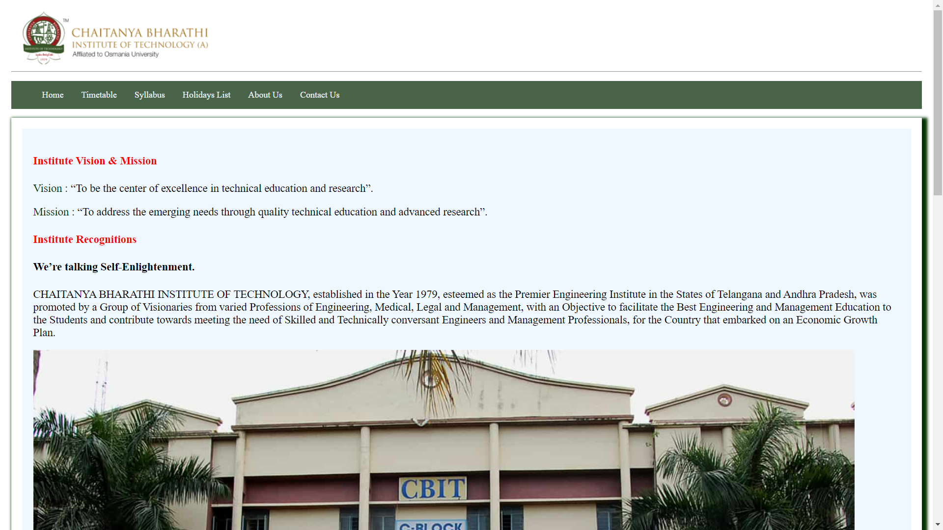

Fig1: Home Page

TimeTable:

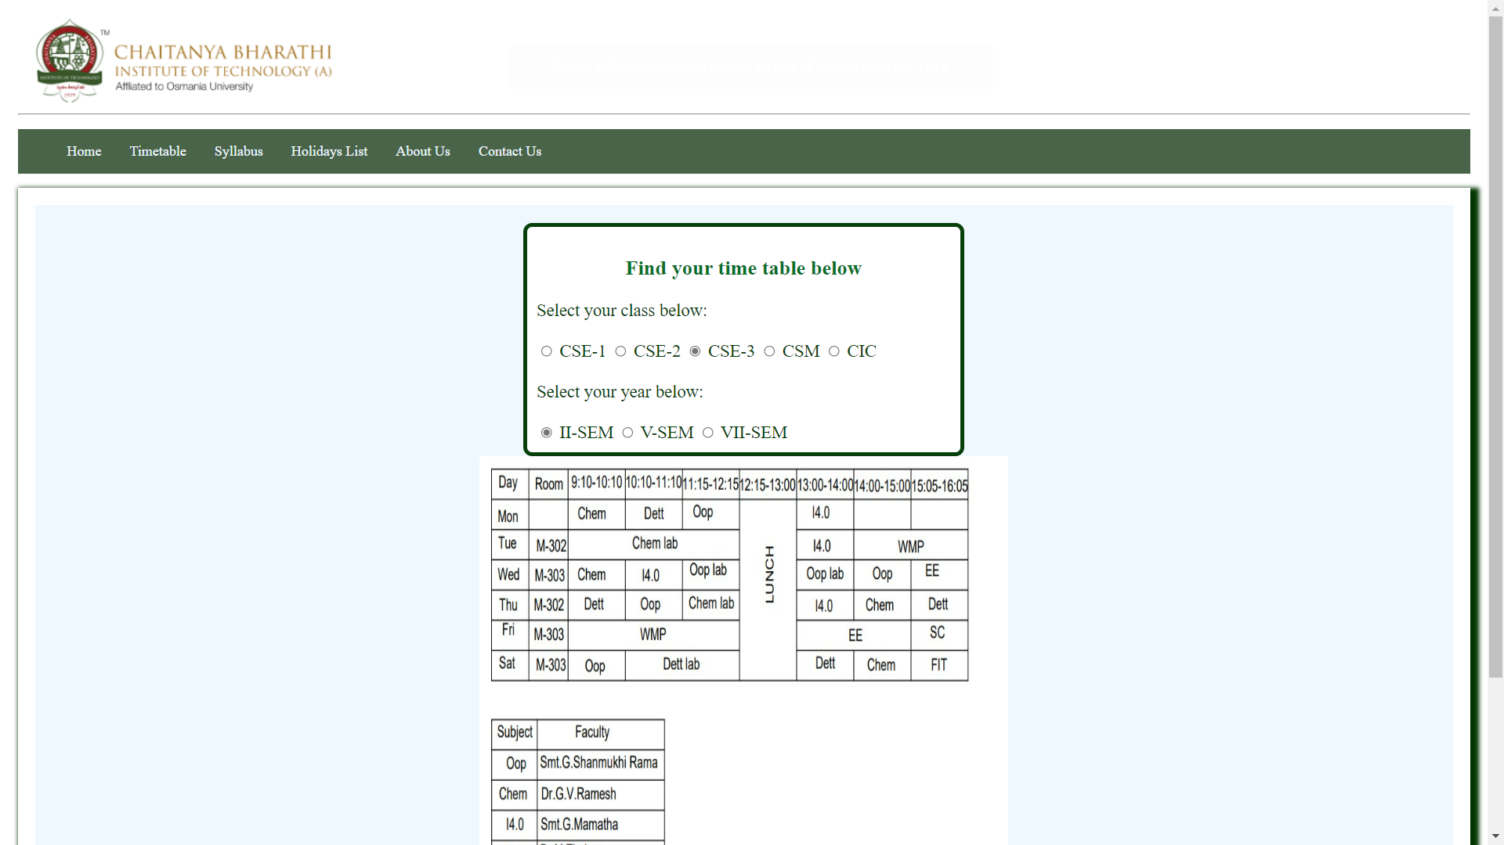

About Us:

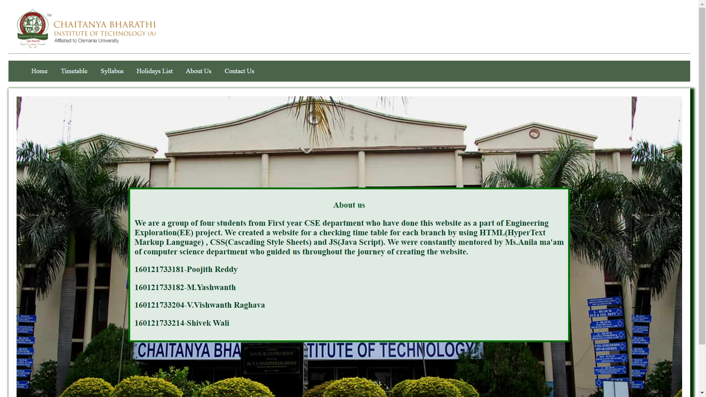

Holidays List:

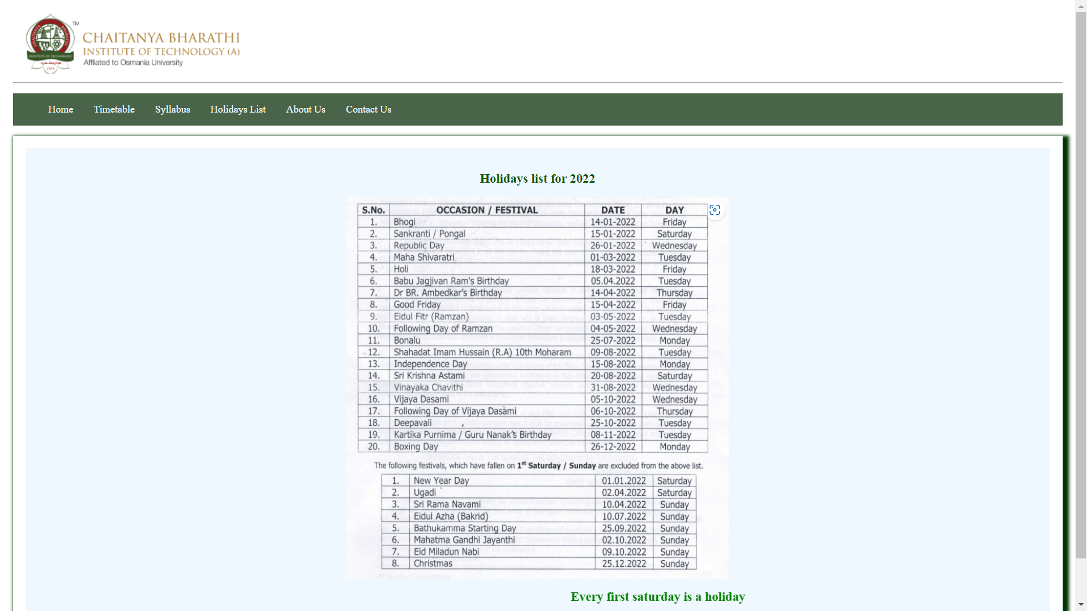

**FUTURE SCOPE**

As we didn’t have much time to create a full-fledged website with backend and integrate this code to a website using amazon cloud services. We plan to develop this website more so that all the students know their attendance and able to access various courses for their study development.

**REFERENCES**

As the part of the research that went into the project, we have used the following sites as references:

1. <https://stackoverflow.com/>
2. <https://www.geeksforgeeks.org/>
3. <https://www.cbit.ac.in/>
4. <https://www.w3schools.com/>

Along with the sites mentioned above we also have used the following YouTube channel as our reference:

1. https://www.youtube.com/results?search_query=apni+kaksha